**Experiment-1**

**Aim: - To design a Test module for an Amazon Web Application**

**i)Home**

**ii)Sign in Page**

**iii)Product Details**

**iv)Payment**

**Summary: -**

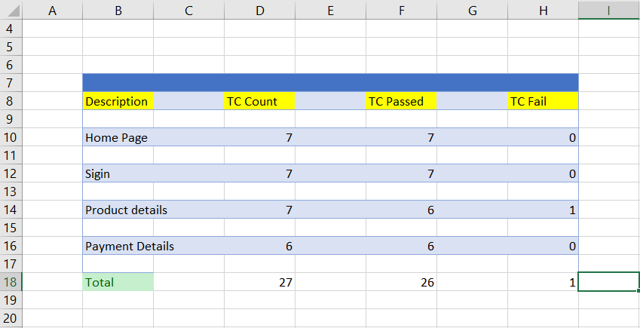

**i) Home Page**

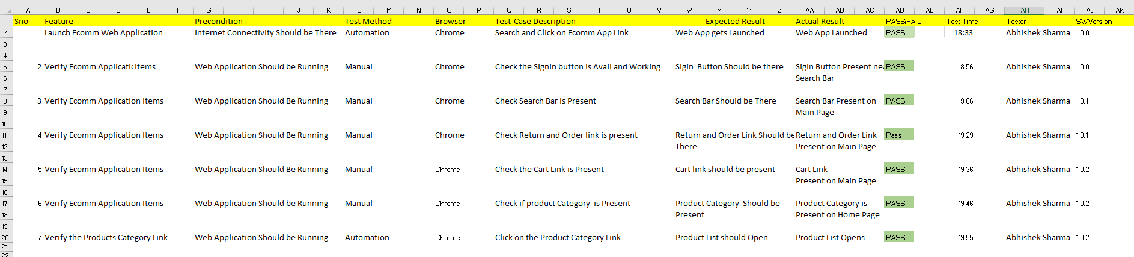

**ii) Sign In Page**

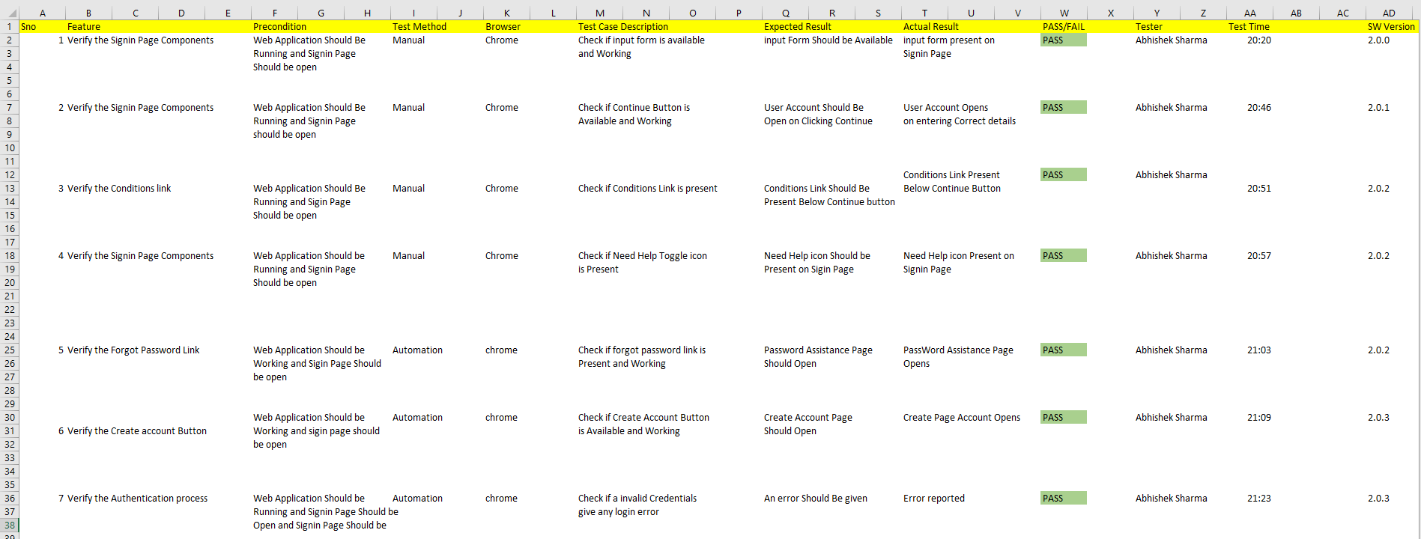

**iii) Product details**

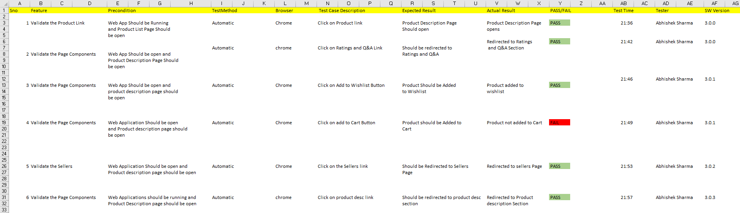

**iv) Payment Details**

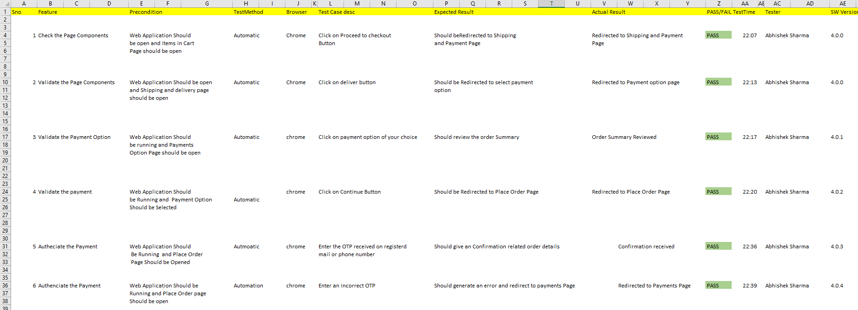

**Experiment – 2 & 3**

**Aim: Build an automation script for registration and login for eCommerce platform.**

**1) Login**

**Code:**

package testSelenium;

import org.openqa.selenium.By;

import org.openqa.selenium.WebDriver;

import org.openqa.selenium.WebElement;

import org.openqa.selenium.chrome.ChromeDriver;

public class EXP_2 {

public static void main(String[] args) throws InterruptedException {

// declaration and instantiation of objects/variables

System.setProperty("webdriver.chrome.driver", "C:\\Users\\dell\\Downloads\\Drivers\\chrome\\chromedriver.exe");

WebDriver driver=new ChromeDriver();

// Launch website

//driver.get("https://www.amazon.in/");

driver.navigate().to("https://www.amazon.in/");

// Click on the search text box and send value

WebElement element = driver.findElement(By.id("nav-link-accountList-nav-line-1"));

element.click();

WebElement email = driver.findElement(By.id("ap_email"));

email.sendKeys("8077490375");

WebElement cont = driver.findElement(By.id("continue"));

cont.click();

WebElement pass = driver.findElement(By.id("ap_password"));

pass.sendKeys("AbhisheK");

WebElement signIn = driver.findElement(By.id("signInSubmit"));

signIn.click();

WebElement search_text = driver.findElement(By.id("twotabsearchtextbox"));

search_text.sendKeys("MI 10t pro");

WebElement search = driver.findElement(By.id("nav-search-submit-button"));

search.click();

WebElement select = driver.findElement(By.className("a-size-medium a-color-base a-text-normal"));

select.click();

}

}

**Screenshots:**

**1) Searching www.amazon.in on web.**

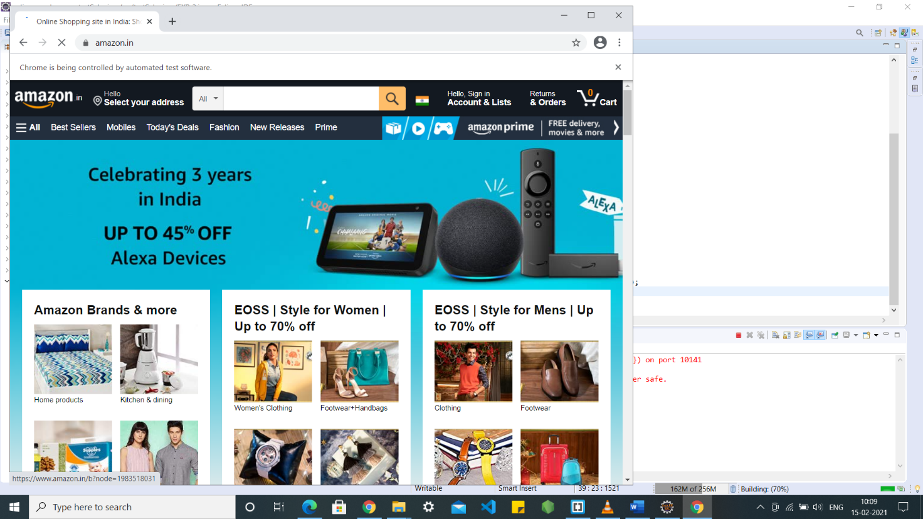

**2) Clicking on the log in button**

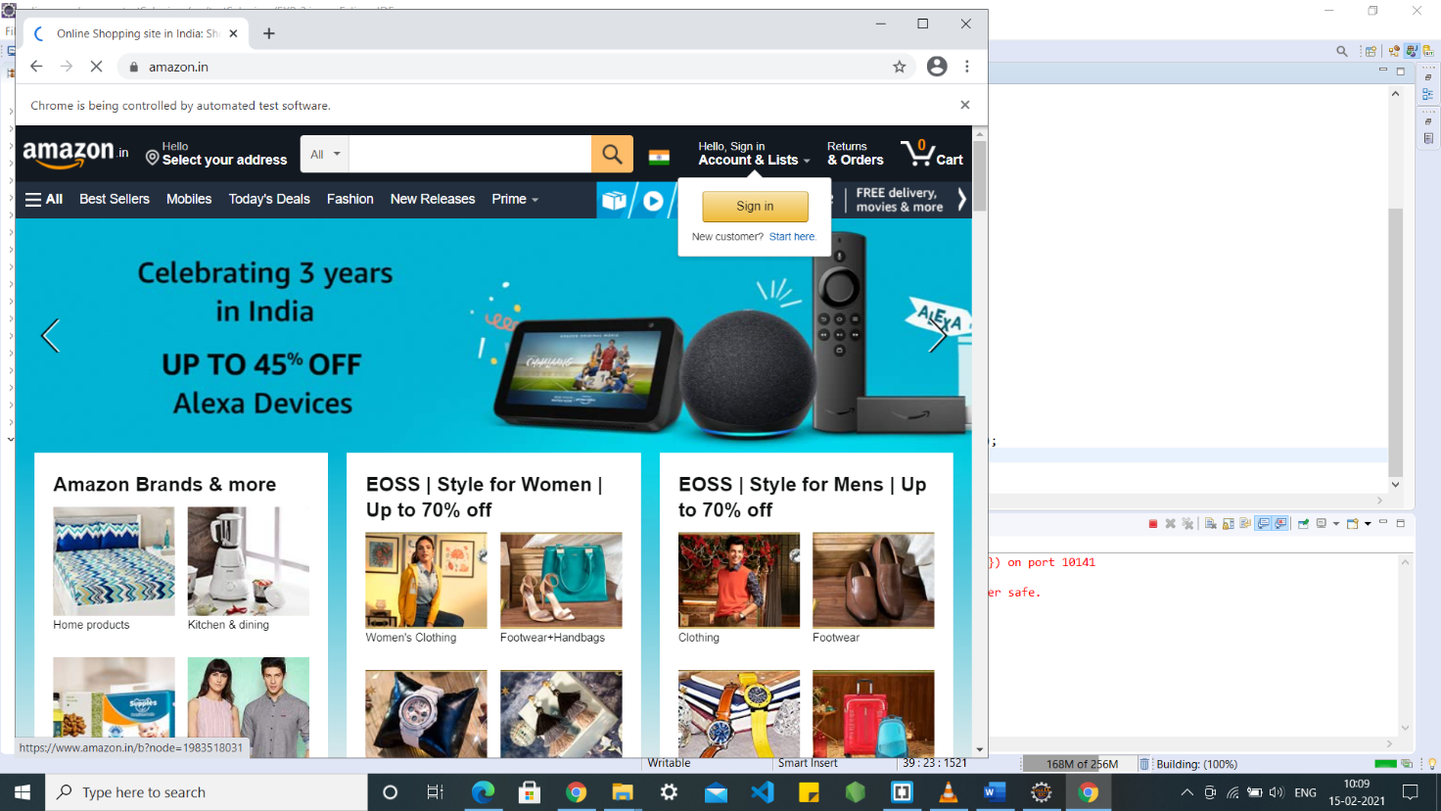

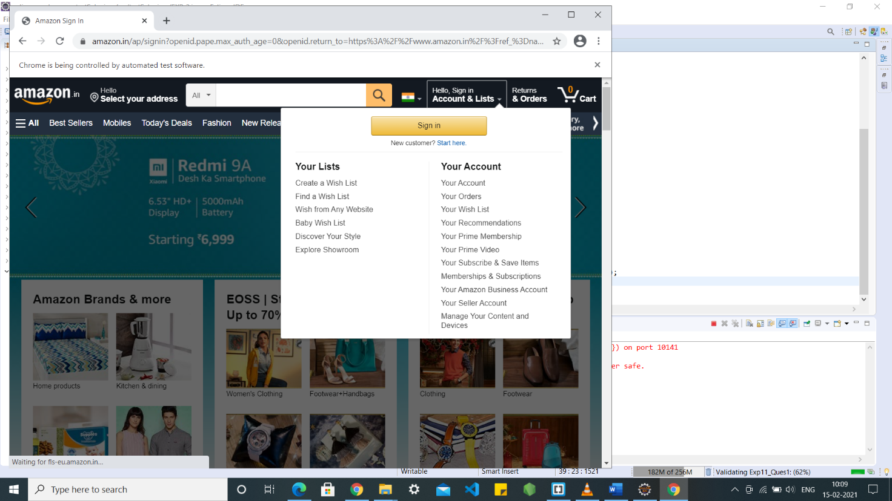

**3) Entering email and password**

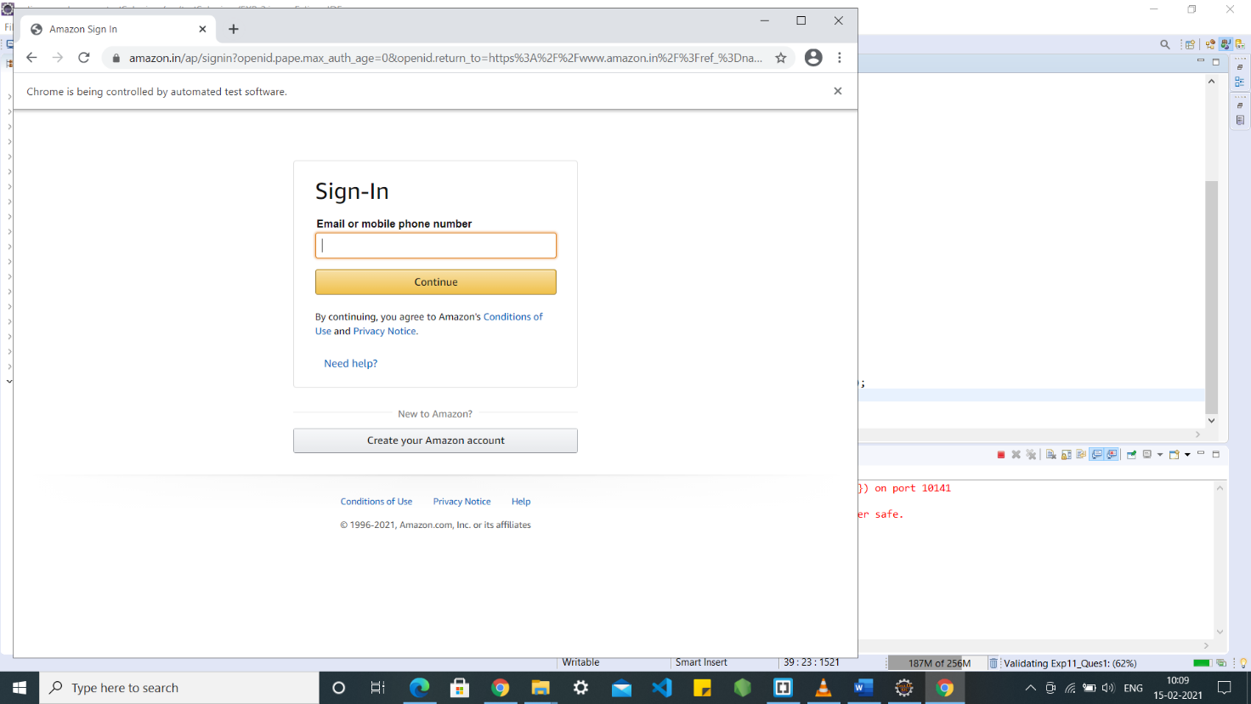

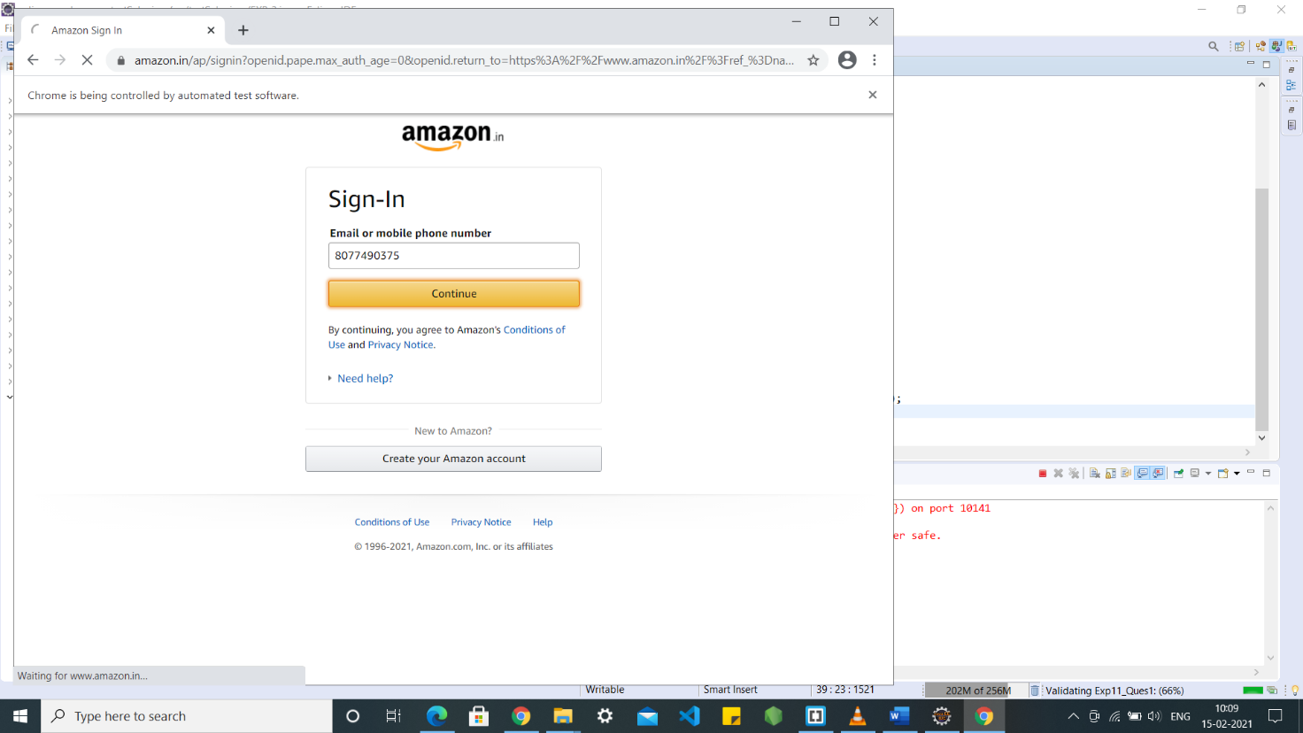

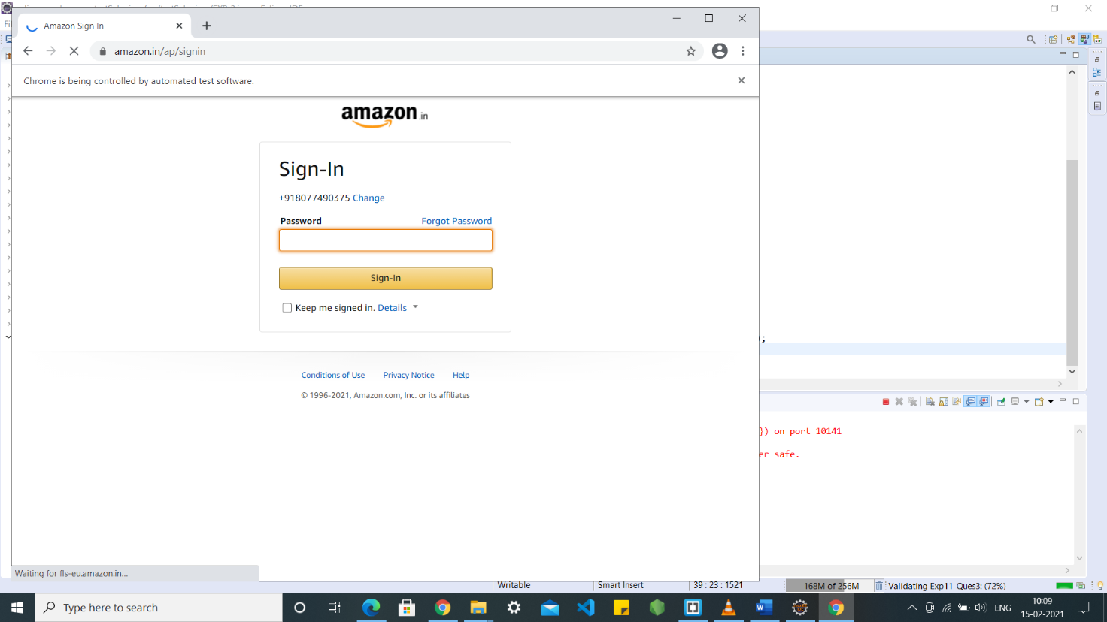

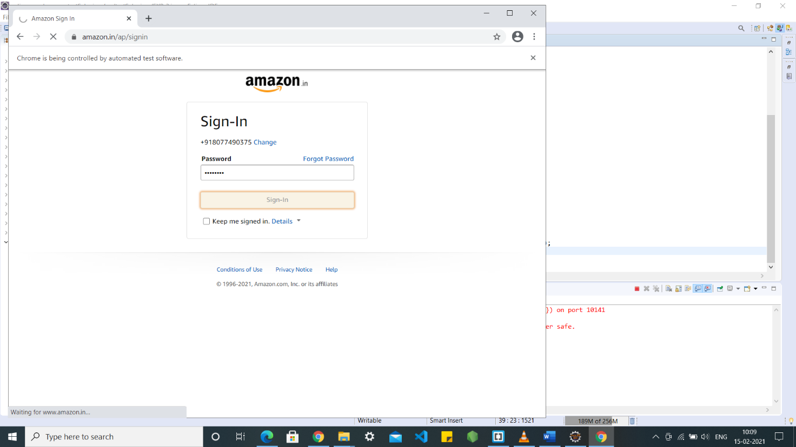

**4) Clicking on submit**



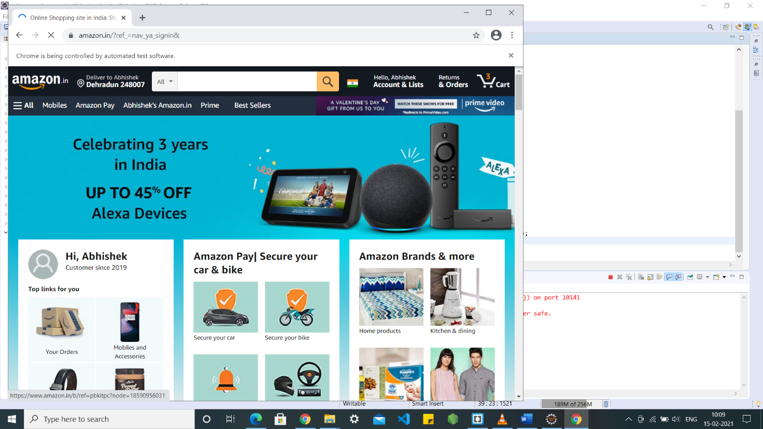

**2) Registration**

**Code:**

package testSelenium;

import org.openqa.selenium.By;

import org.openqa.selenium.WebDriver;

import org.openqa.selenium.WebElement;

import org.openqa.selenium.chrome.ChromeDriver;

public class Register_Class {

public static void main(String[] args) throws InterruptedException {

// declaration and instantiation of objects/variables

System.*setProperty*("webdriver.chrome.driver", "C:\\Users\\dell\\Downloads\\Drivers\\chrome\\chromedriver.exe");

WebDriver driver=new ChromeDriver();

driver.navigate().to("https://www.amazon.in/");

WebElement hellosignin = driver.findElement(By.*id*("nav-link-accountList"));

hellosignin.click();

WebElement acc = driver.findElement(By.*id*("createAccountSubmit"));

acc.click();

WebElement name = driver.findElement(By.*id*("ap_customer_name"));

name.sendKeys("Abhishek Sharma");

WebElement number = driver.findElement(By.*id*("ap_phone_number"));

number.sendKeys("877490375");

WebElement pss = driver.findElement(By.*id*("ap_password"));

pss.sendKeys("AbhisheK");

WebElement con = driver.findElement(By.*id*("continue"));

con.click();

} }

**Screenshots:**

**1) Going to www.amazon.in**



**2) Clicking on the button to register**

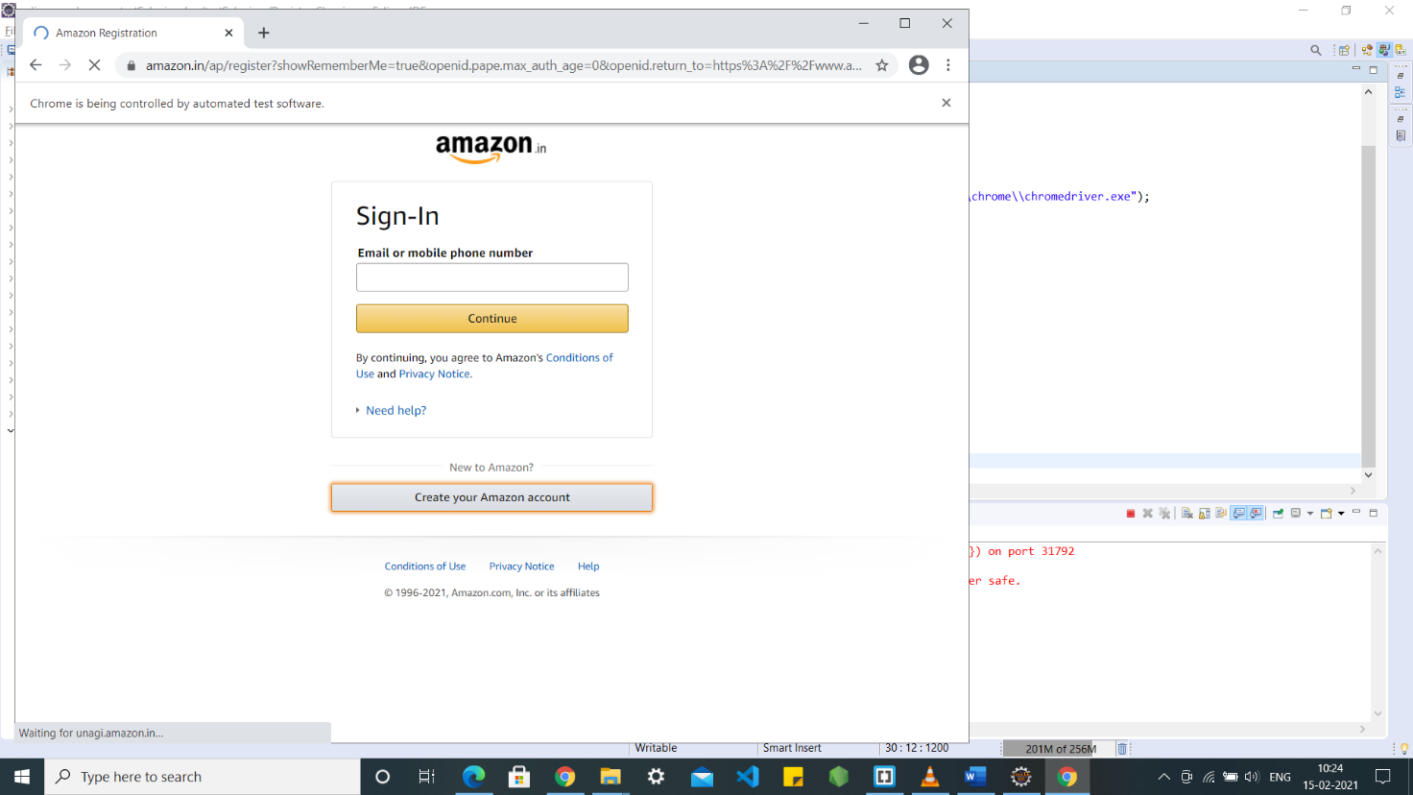

**3) Entering details and pressing continue**

